Table of Contents

1.1 Introduction 2

1.1.1 Prerequisites 2

1.2 Revenue Analysis (Order Dashboard) 3

1.2.1 Revenue Breakdown. 3

1.3 Product Analysis (Products Dashboard) 6

1.3.1 Product Analysis breakdown 6

1.4 Customer Analysis (Accounts Dashboard) 9

1.4.1 Account Analysis breakdown 9

1.5 Invoice Analysis (Invoice Dashboard) 14

1.5.1 Invoice Analysis breakdown 15

1.6 Feedback Analysis (Customer Feedback Dashboard) 19

1.6.1 Feedback Analysis breakdown 20

2 Summary of Business Problem and Recommendations 23

**Case Study: Piespace Company**

## Introduction

In this case study, an analysis of the key performance indicators (KPIs) for Piespace Company will be carried out based on a sample database found in Metabase. The database consists of the following tables.

* **Accounts**
* **Analytic Events**
* **Feedback**
* **Invoices**
* **Orders**
* **People**
* **Products**
* **Reviews**

By examining the data within these tables, we aim to gain insights into various aspects of Piespace's company business operations and identify areas for improvement and visualization using the Metabase visualization tool.

KPIs are crucial metrics that provide organizations with quantifiable measurements of their performance. They help in assessing the effectiveness of strategies, evaluating the achievement of goals, and guiding decision-making processes. By analyzing the data in the Piespace Company's database, we will focus on several KPIs that are essential for their business success.

### Prerequisites

1. **Clean data:** The data in the sample database was already cleaned and normalized; no further data cleaning or normalization.
2. **Model Creation:** Models are vital in relationship management between tables and simplifying querying.

-Three models Joins were created that allowed easy reference of cross table columns

1. Use Left Joins to connect the **Orders + Products** Tables on the ID column.
2. Use Left Joins to connect the **Accounts + Feedback** Tables on the ID column.
3. Used Left Join to connect the **Analytic Events + Account** Tables on the ID column.

## Revenue Analysis ([Order Dashboard](http://35.223.113.136:3000/dashboard/7-orders-dashbaord))

Revenue analysis involves studying various key performance indicators (KPIs) related to revenue, such as total revenue, average order value, revenue growth rate, revenue by product category, and revenue by number of orders from categories.

These KPIs help measure the performance of different aspects of revenue generation and provide valuable insights into customer behavior, market trends, and the impact of various factors on revenue.

*\*\*Definition of Terms*

* ***Total Revenue:*** This KPI measures the overall revenue generated from all orders. It provides an overview of the business's financial performance.
* ***Average Order Value (AOV):*** AOV calculates the average revenue generated per order. It helps understand customer spending patterns and can be used to track changes over time.
* ***Revenue by Product/Service:*** This KPI breaks down revenue by individual products or services. It helps identify the most profitable offerings and highlights areas for improvement or expansion.
* ***Revenue by Geography:*** Breaking down revenue by geographical regions or locations helps identify high-performing markets and target areas for growth or expansion.
* ***Total Tax:*** shows the total tax incurred by the business.

### Revenue Breakdown.

**Piespace** had a set-theoretical **Revenue target** of **$3M \*\***

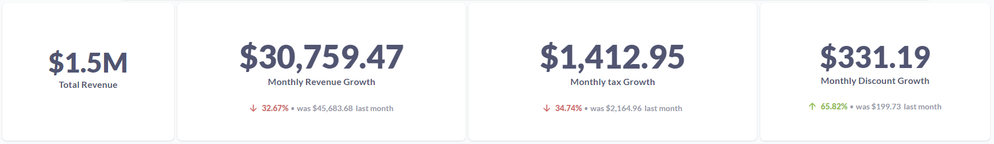

#### Key takeaways

1. This month’s Total revenue was **$1.5M**, where the Total monthly Revenue **decreased** from **$45,683 to $30,759** representing a **32.67%** **decrease.**
2. The monthly Tax dropped by **34.74%** this month from **$2,164 to $1,412.**
3. This month’s collective discount growth **increased** by **65.82%** from **$199.73** to **$331.19.**
4. Piespace company fell short of its monthly revenue target of **$3M** and achieved **$1.5M**



1. The Total and Net monthly revenue have been on a steady rise since 2017 with **peak** monthly revenue of **$52.3k** achieved in **January 2020.**

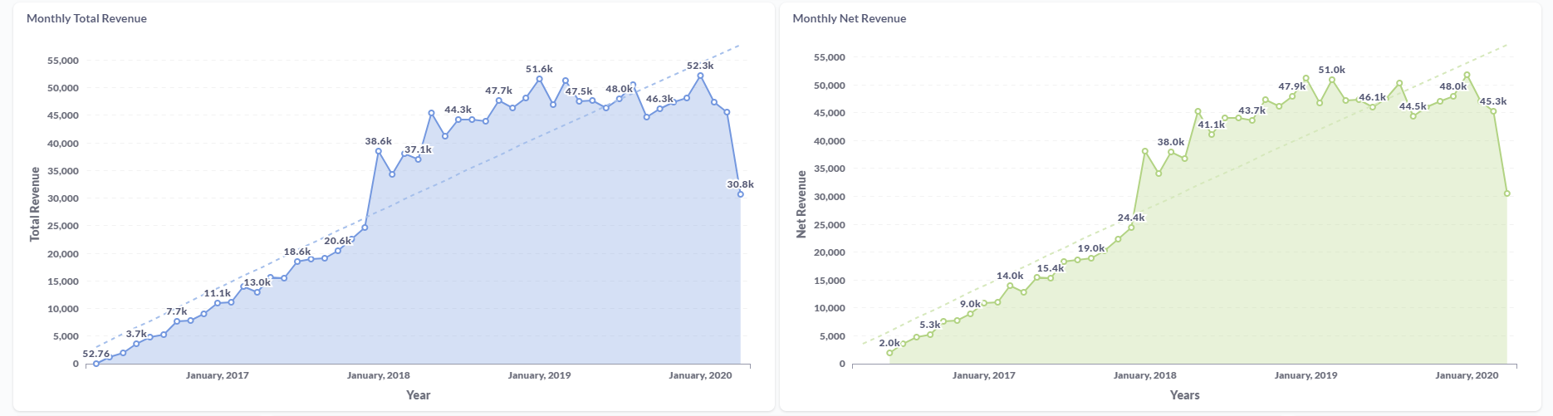

6. **Revenue by Product category:** The **Widget** and **Gadget** category are the **highest** Revenue earners at **$423.7k** and **$406.6k** respectively while the **Gizmo** and **Doohicke**y come in at **$383.1k** and **$297.3k** respectively.

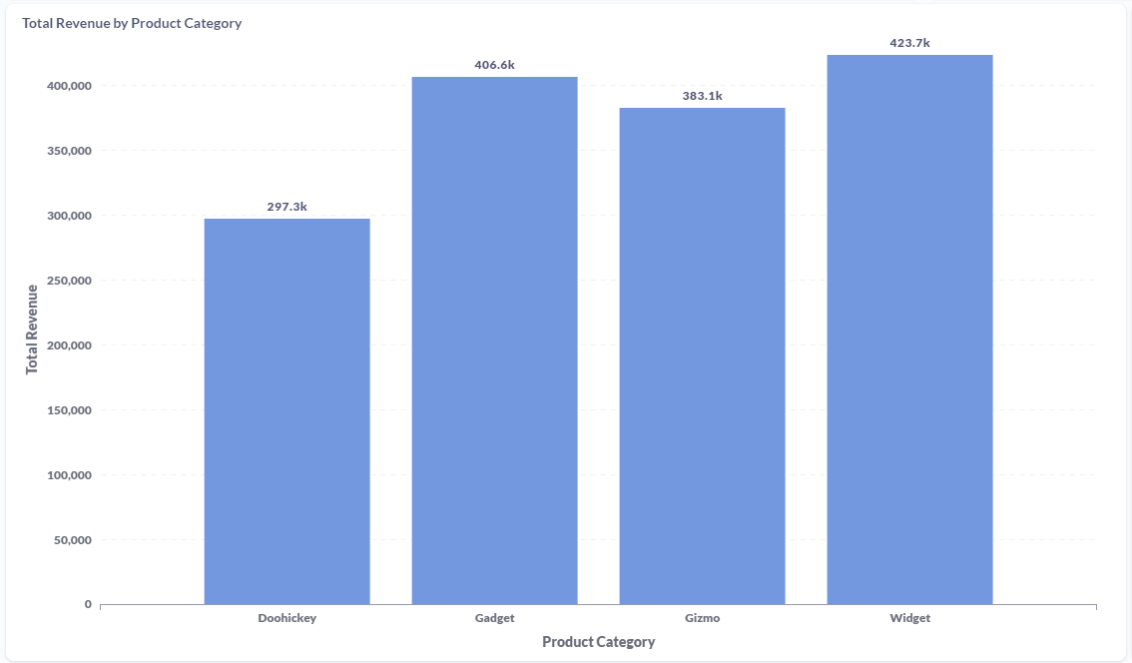

6. **Number of orders: Doohickey** and **Gizmo** are the only products to record a **rise** in orders from the previous quarter at **16.04%** and **14.94%** respectively while **Gadgets** and **Widgets** recorded a drop in orders at **53.65%** and **43.61%** respectively from the previous quarter.

7. The monthly order value fell by **14.97%** from **$246.19** to **$209.33.**

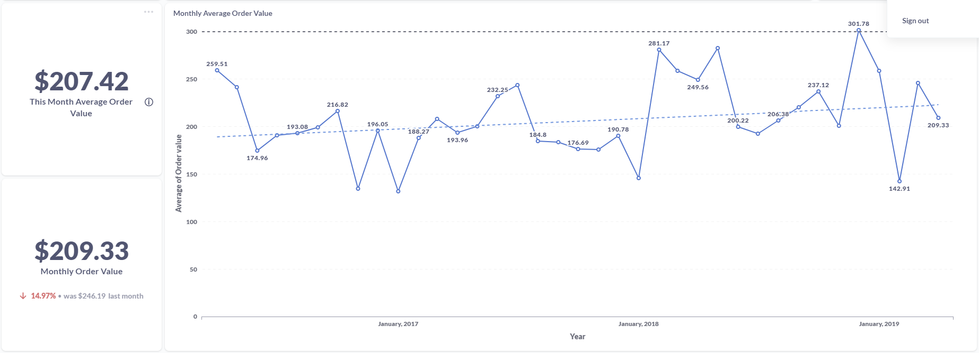

8. USA was the largest revenue generator by country at **$212,585.96**

## Product Analysis ([Products Dashboard](http://35.223.113.136:3000/dashboard/12-products-dashboard))

The primary objective of product analysis is to gain a comprehensive understanding of how products are performing in the market and identify opportunities for improvement, optimization, and growth. It involves studying factors such as sales data, customer feedback, market trends, and competitive landscape to make informed decisions about product strategies, pricing, marketing, and development.

The KPIs used in Piespace product analysis include product rating, product price per category, units sold, and product performance index.

*\*\*Definition of Terms*

* ***Product Rating:***Product Rating is a KPI that measures the satisfaction or feedback of customers regarding a specific product.
* ***Product Price per Category:*** Product Price per Category is a KPI that measures the average price of products within a specific category or group.
* ***Units Sold:*** Units Sold is a KPI that measures the total number of individual products sold over a specific period.
* ***Product Performance Index:*** The product Performance Index is a KPI that ranks products based on their overall performance and success. It is calculated by considering various factors such as sales volume, revenue generated, customer satisfaction, market share, and other relevant metrics.

### Product Analysis breakdown

***Piespace Expected Targets:***

1. The total Quantity Sold set between 2,500 - 3,000 Units per month.
2. Average Product rating: 4 stars

#### Key takeaways

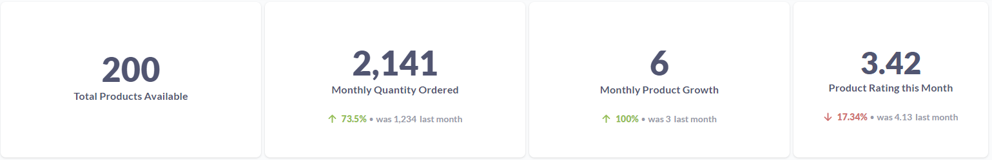

1. The company had **200 products** in its catalog.
2. Monthly units ordered **increased** by **73.5%** from **1,234 units to 2,141 units.**
3. **The average** product rating fell by **17.34% from 4.13 to 3.42.**
4. Monthly product growth in the catalogue **increased** by **6** representing a **100% rise.**
5. The monthly product quantity target **(2,500)** has been achieved **5 times** over the last **3 years.**

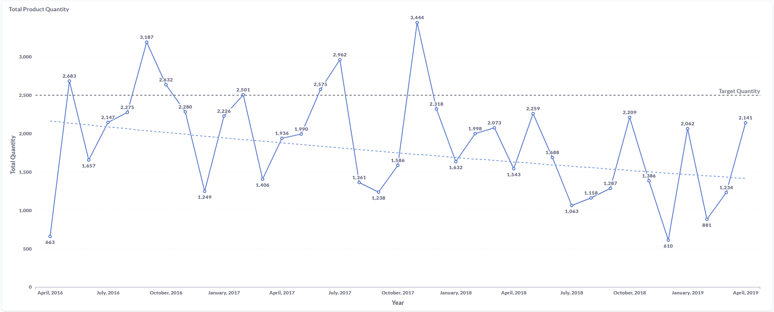

1. Quantity of units broken down by Products (Demand): The **Doohickey** and **Gizmo** products recorded **an increase** in quantity ordered at **10.53%** and **7.01%** respectively in the last quarter while the gadget and widget products recorded a **decrease** of **59.86%** and **46.63%** respectively taking **third** and **fourth** place.

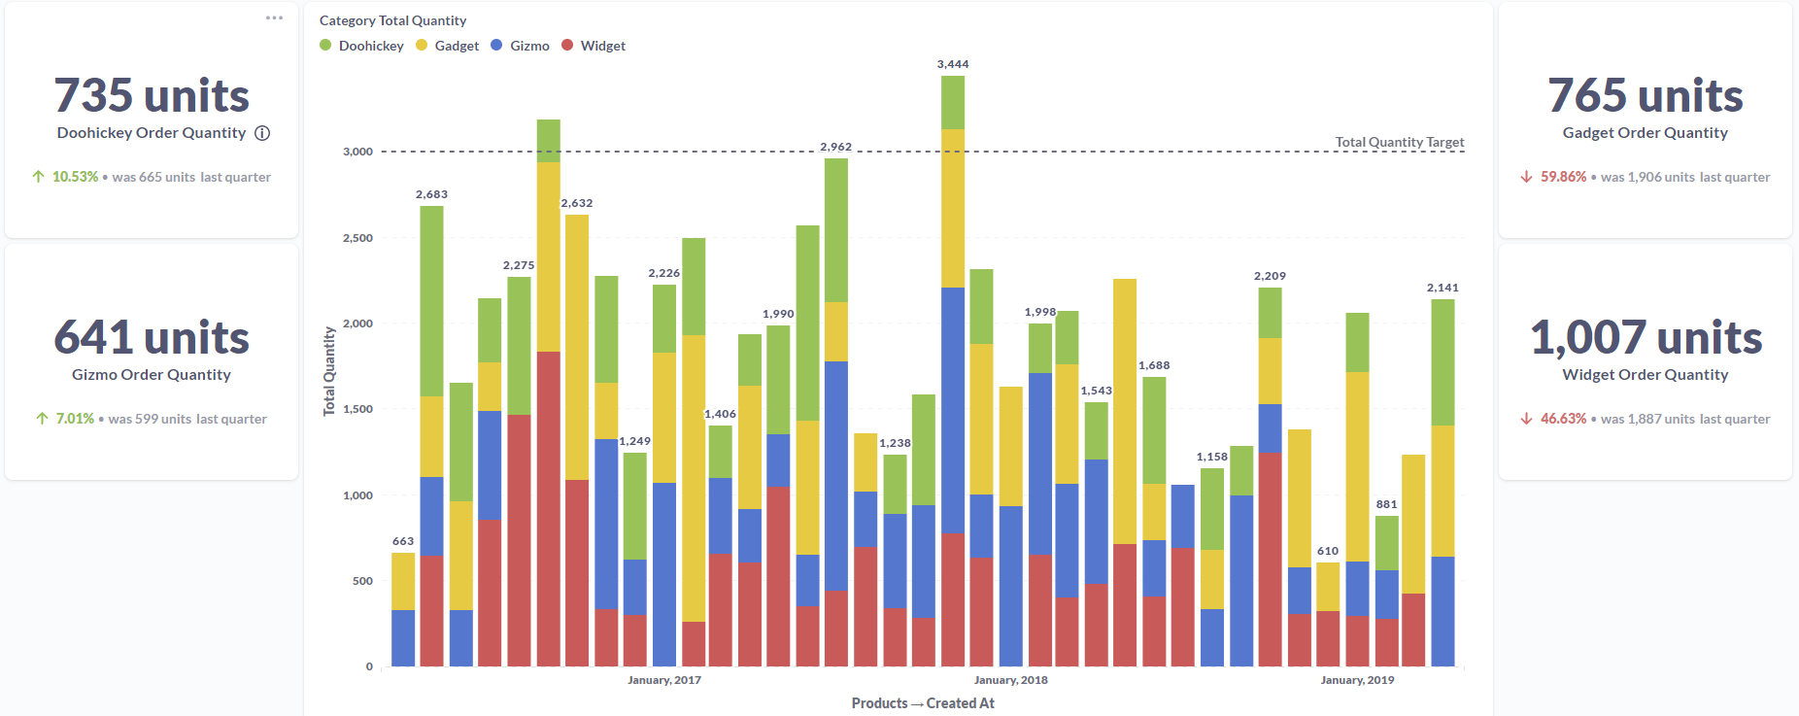

1. The **Gizmo** product was the **highest** rated at **4.05** in **201**9, the **Doohickey** the **highest** in **2018** at **4.01**, and also in **2017** and **2016** at **4.05** and **3.45** respectively.

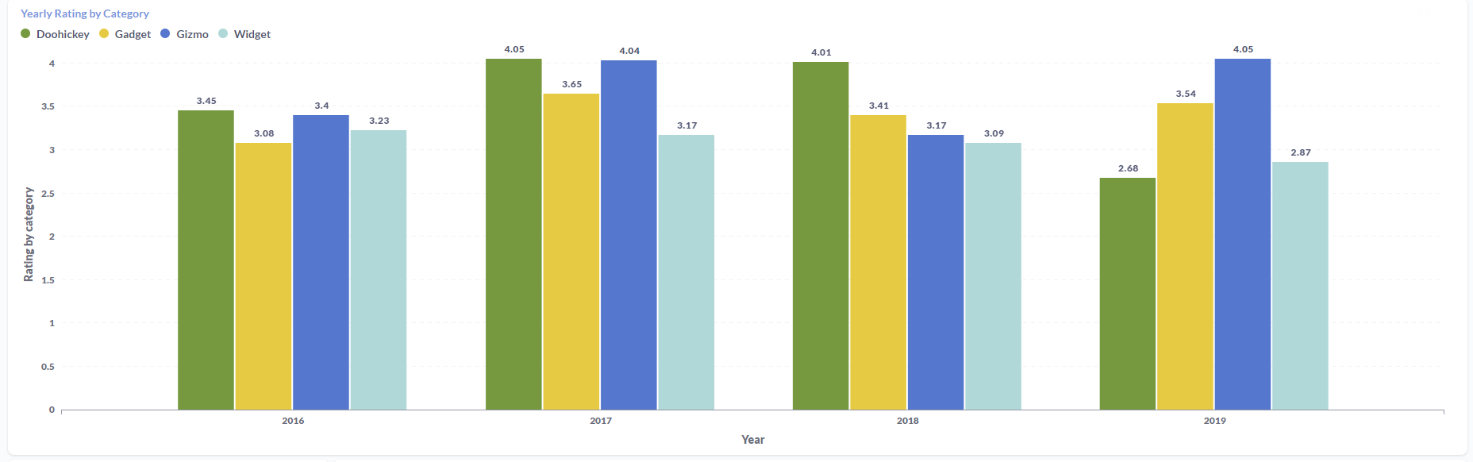

1. Piespace met its **4-star** product rating **14** times since **2016**, while only achieving the set target once in **2019**.

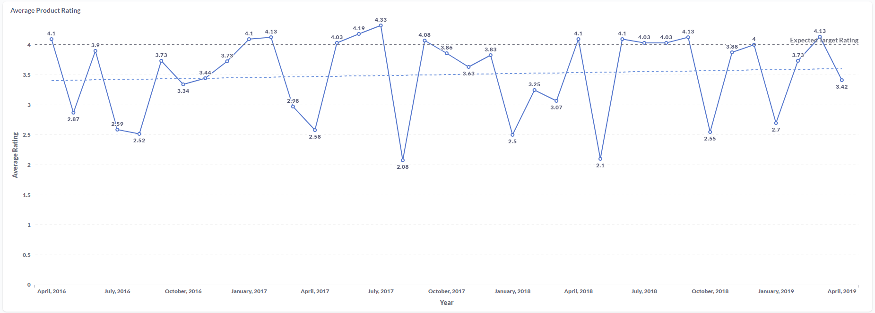

1. The **highest** average product price in the category section was **Widget** at **$57.58**, Gadget **second** at **$56.97** and **Gizmo** and **Doohickey** **third** and **fourth** at **$55.59** and **$52.04** respectively.

## Customer Analysis ([Accounts Dashboard](http://35.223.113.136:3000/dashboard/3-accounts-dashboard))

Customer analysis is a process that involves examining and understanding the characteristics, behaviors, needs, and preferences of customers. It focuses on analyzing customer data to gain insights into customer segments, purchasing patterns, satisfaction levels, and overall customer experience.

These KPIs include Monthly User growth, Active subscriptions, Trial conversion rates, Account cancellation rate, plan distribution, subscription source, and click behavior.

*\*\*Definition of Terms*

* ***Monthly User Growth:*** This KPI measures the rate at which the user base of a product or service grows monthly.
* ***Active Subscriptions:*** This KPI tracks the number of active subscriptions to a product or service during a specific period.
* ***Trial Conversion Rates:*** This KPI measures the percentage of trial users who convert into paying customers after a trial period.
* ***Account Cancellation Rate:*** This KPI measures the rate at which customers cancel their accounts or subscriptions.
* ***Plan Distribution:*** This KPI analyzes the distribution of customers across different subscription plans or pricing tiers.
* ***Subscription Source:*** This KPI tracks the sources or channels through which customers initially sign up for a subscription.
* ***Click Behavior*:** This KPI measures user engagement and interaction within a digital platform by analyzing click behavior. It tracks user actions, such as clicks on specific features, links, or content. Click behavior metrics include click-through rates, time spent on different pages, and click patterns. Analyzing click behavior provides insights into user preferences, feature usage, and user experience optimization opportunities.

### Account Analysis breakdown

***Piespace Expected Targets:***

1. Piespace New Monthly user growth by seats set at 5,000.

#### Key takeaways

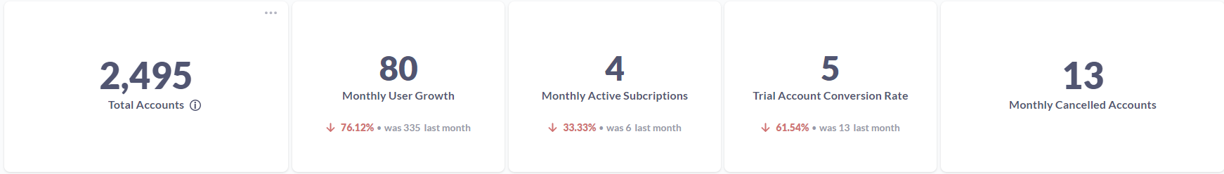

1. The total user accounts stand at **2,495.**
2. The monthly account growth rate **dropped** by **76.12%** from new **335** users to new **80** users.
3. The number of active subscribers **dropped** by **33.33%** from **6** to **4.**
4. The account trial conversion rate **dropped** by **61.54%** from **13** to **5.**
5. Accounts **canceled** this **month** were **13.**
6. Piespace met its new account growth by seats only **2 times.**

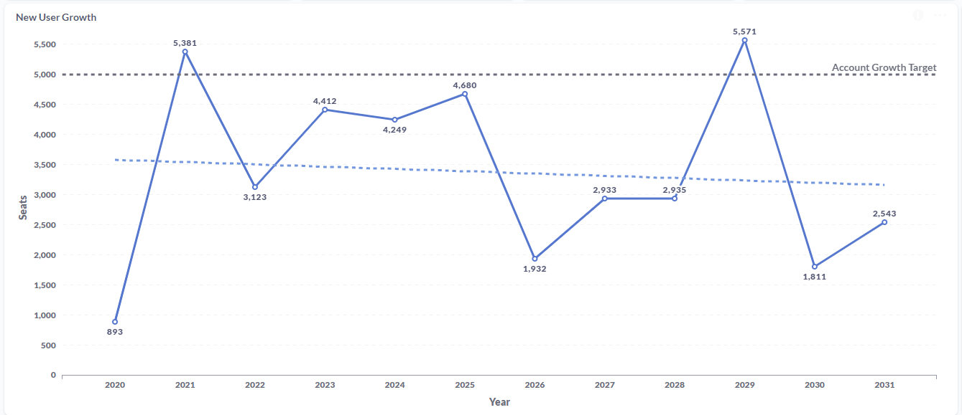

1. **Account distribution**:

The **Basic** account plan was the **highest** at **2,378 users**, the **Premium** plan **second** at **86 users** and the **Business** plan the **leas**t subscribed at **31 users.**

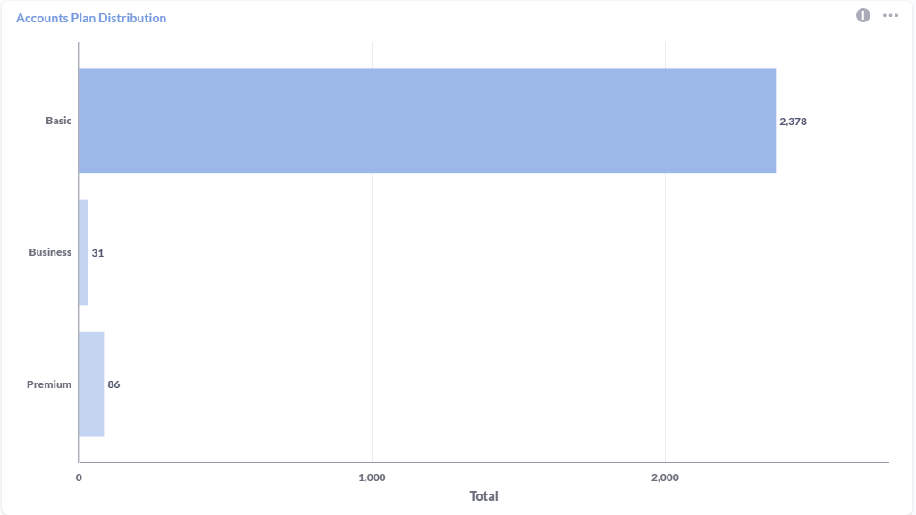

1. **Customer Retention:**

-**55%** of users **converted** to paid plans after the expiry of the trial period while **45%** did **NOT** continue to pay after the trial period expired this month.

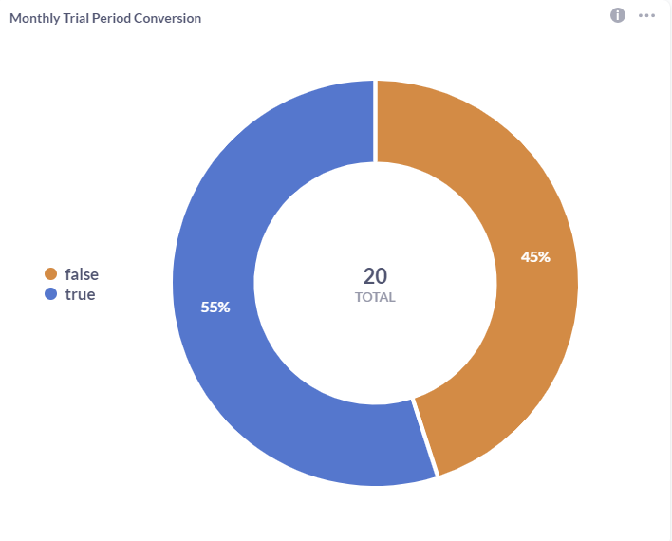

-New user accounts preferred to subscribe via **Invitation (436)** and **least** preferred to subscribe by **Facebook (390).**

-Google had the **highest** conversion numbers **(3,556)** from Users who Renewed their trial period after subscribing while **Twitter (1,867)** was the **least effective method** of converting these new users.

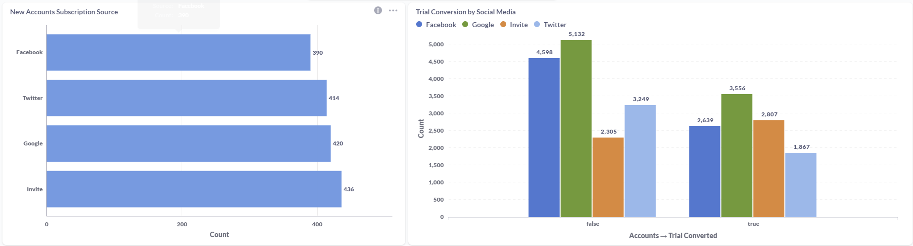

1. **Customer behavior:**

* 86% of new users viewed the page only, and 14% of the new users clicked on the buttons within the website.

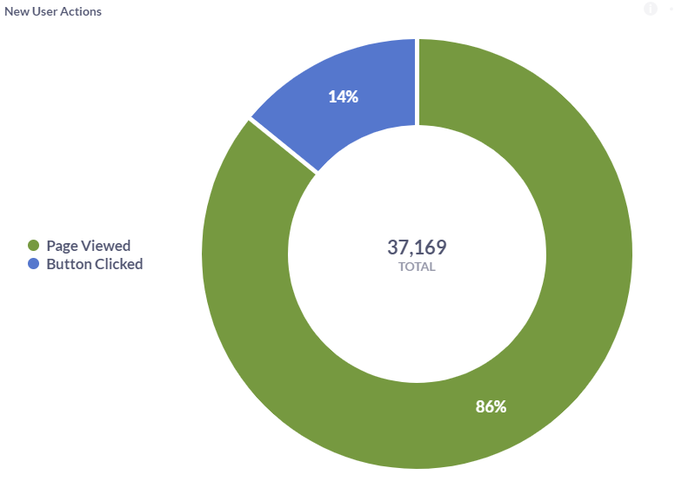

* Of the 14% of users who clicked on a button; **20.66%** created an **item**, **20.51%** clicked the **invite button**, **20.27%** clicked the **subscribe button**, **19.75%** clicked the **sign-up button** and **18.81%** clicked on the **check-out button.**
  + - 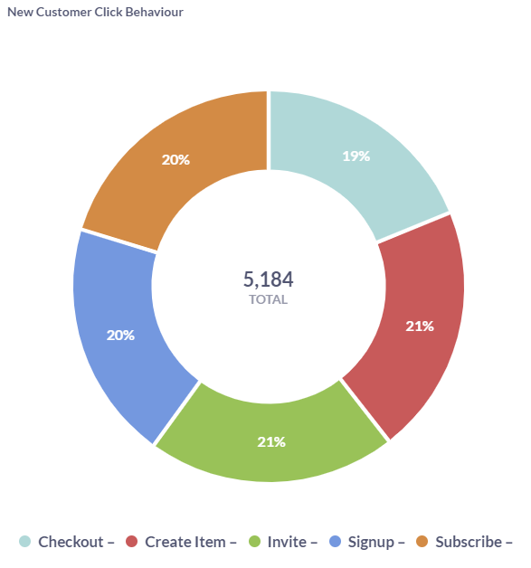

## Invoice Analysis ([Invoice Dashboard](http://35.223.113.136:3000/dashboard/11-invoice-dashboard))

Invoice analysis is a critical process in a business that involves the examination and interpretation of invoice data to gain insights into the financial aspects of a company's transactions. It focuses on understanding and evaluating the invoicing process, payment patterns, and overall revenue generation.

The primary objective of invoice analysis is to ensure accuracy, efficiency, and effectiveness in the invoicing process. By analyzing invoice data, businesses can identify areas for improvement, optimize cash flow management, minimize payment delays, and enhance customer satisfaction.

These KPIs include Invoice growth, Average invoice payments, monthly invoices received, total expected invoice value, monthly invoice growth, invoice per plan, and invoice payment by active and non-active subscribers.

*\*\*Definition of Terms*

* ***Invoice Growth:*** Invoice Growth measures the percentage increase or decrease in the number of invoices generated over a specific period.
* ***Average Invoice Payments:*** Average Invoice Payments calculate the average amount received as payment for each invoice.
* ***Monthly Invoices Received:*** Monthly Invoices Received measure the total number of invoices received within a specific month.
* ***Total Expected Invoice Value:*** Total Expected Invoice Value calculates the sum of the expected payment amounts across all invoices.
* ***Monthly Invoice Growth:*** Monthly Invoice Growth measures the percentage increase or decrease in the number of invoices generated monthly.
* ***Invoices per Plan:*** Invoices per Plan measure the number of invoices generated per pricing plan or service tier.
* ***Invoice Payment by Active and Non-active Subscribers*:** Invoice Payment by Active and Non-active Subscribers compares the payment behavior of customers with active subscriptions to those with inactive or canceled subscriptions. It helps assess the payment reliability of different customer segments and highlights any differences in payment patterns between active and non-active subscribers.

### Invoice Analysis breakdown

***Piespace Expected Targets:***

1. The set monthly target for new invoices is **500**.
2. The set monthly target for the new Invoice value is **$180,000.**

#### Key takeaways

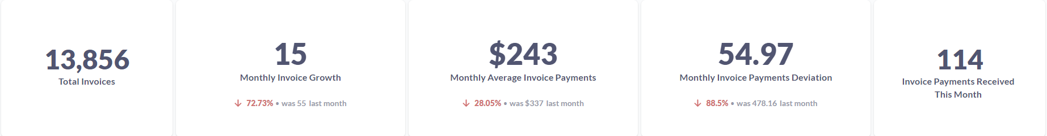

1. The total invoices stand at **13,856** where **114** invoices were received this month.
2. Monthly Invoices **dropped** by **72.73%** from **55** to **15.**
3. The monthly average invoice value **dropped** by **28.08%** from **$337** to **$243.**
4. The standard deviation of the invoice value **dropped** by **85.5%** from **478.16** to **54.97.**
5. The company failed to hit the **500** new invoices target for the past 10 years.

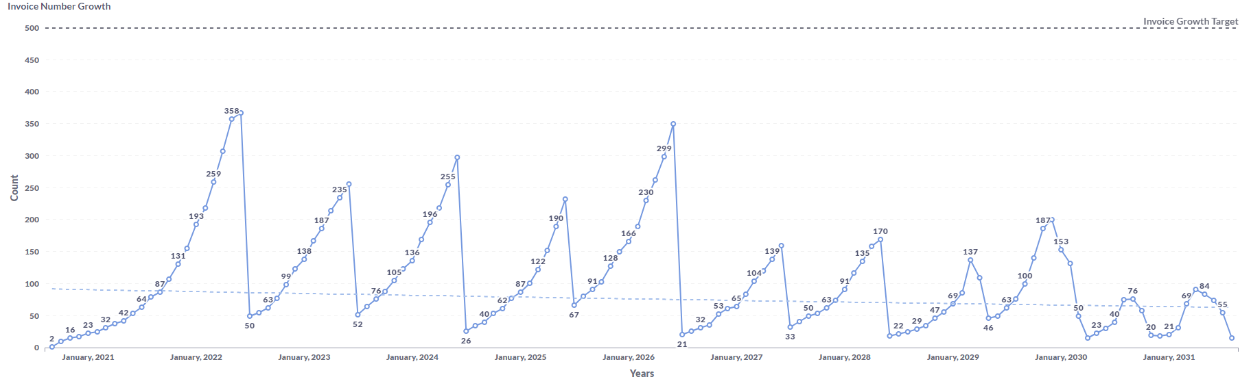

1. The total invoice value stands at **$6,704,097**. The monthly invoice value **decreased** by **80.38%** from **$18,545** to **$3,639.** Invoice value milestones were hit twice over the last 10 years.

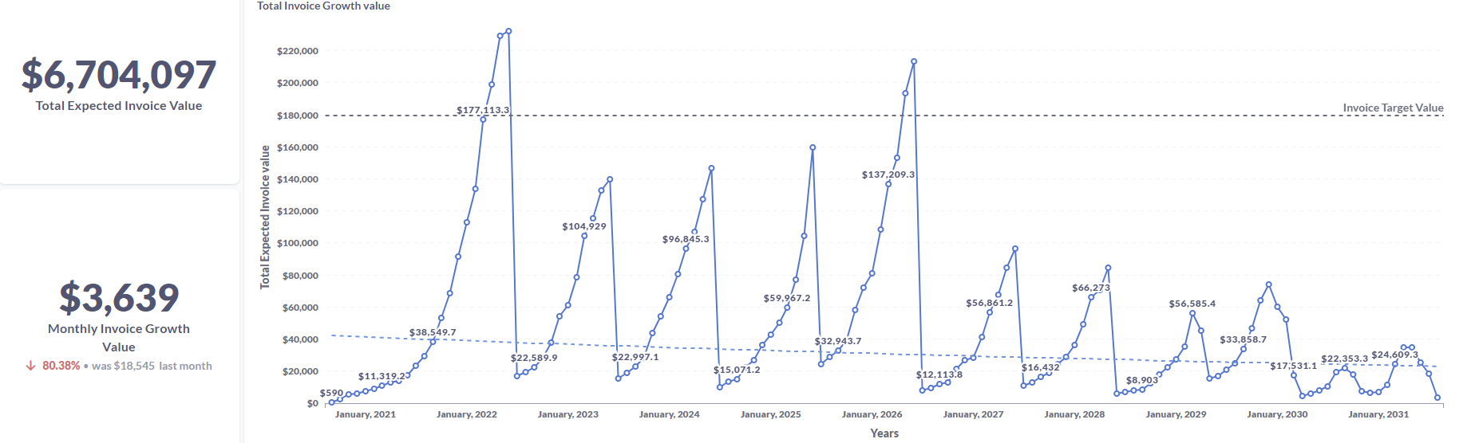

1. **13,401 users** paid their invoices compared to **455** who failed to pay their invoices. The **highest** monthly invoice stands at **$295,** a **92.23%** **decrease** while the **lowest** stands at **$42.7** an **81.76%** decrease.

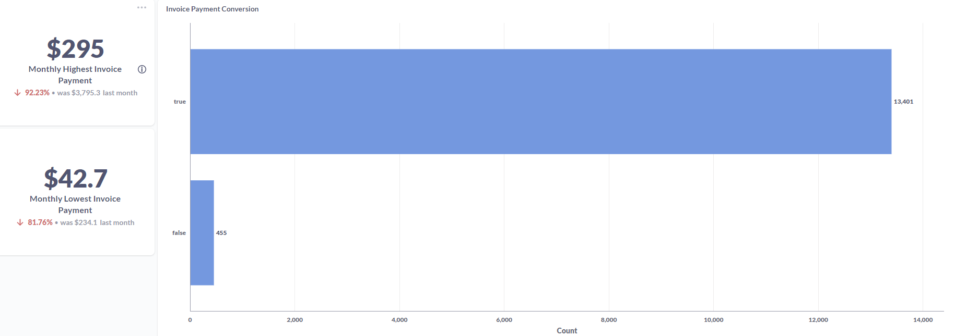

1. The **Basic plan** had the **highest** number of invoices at **12,579**, the **Business plan at 1,083,** and **the Premium plan** at **194.**

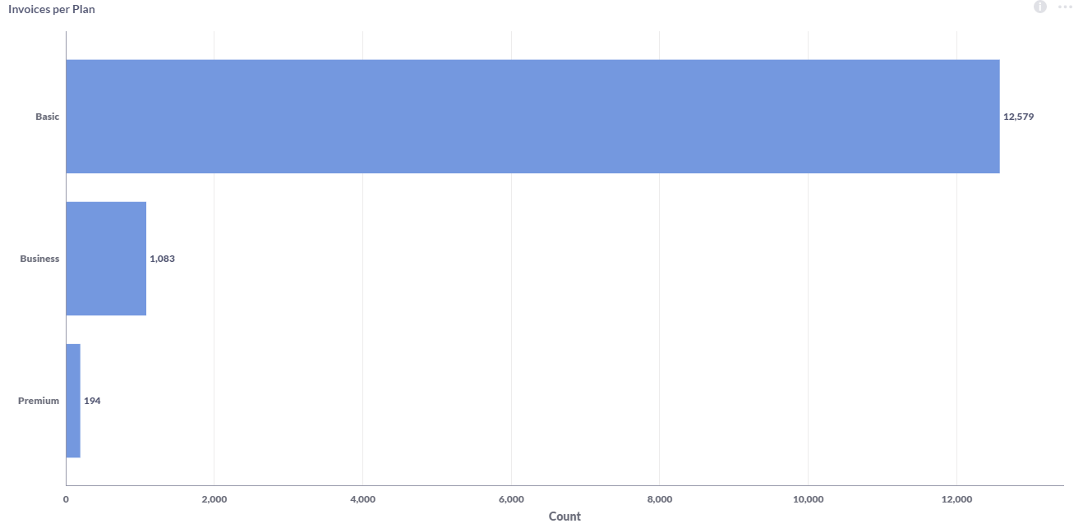

1. **96.66% of non-active** subscribers paid their invoices while **3.34%** failed to pay them.

.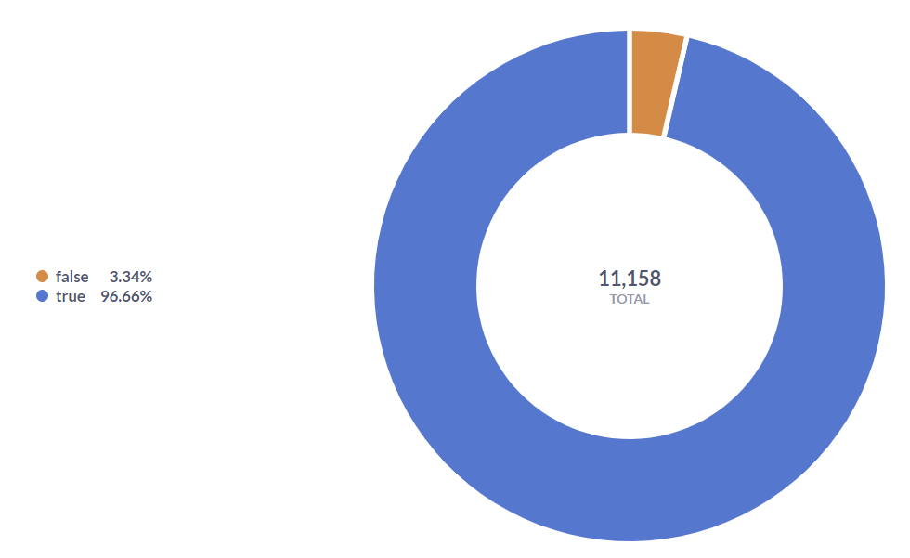

1. **96.96% of Active subscribers** paid their invoices while **3.04%** failed to pay their invoices.

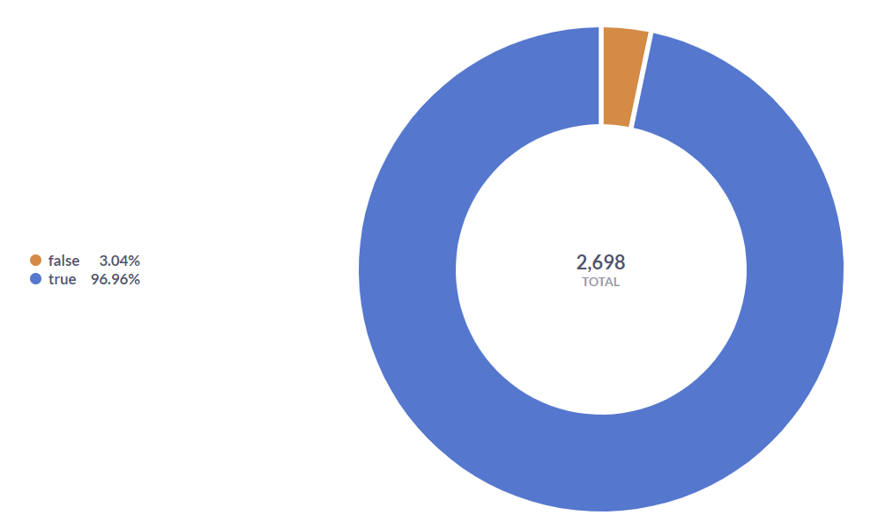

## Feedback Analysis ([Customer Feedback Dashboard](http://35.223.113.136:3000/dashboard/15-customer-feedback))

The primary objective of feedback analysis is to transform raw feedback data into actionable insights. By analyzing feedback, businesses can uncover valuable information about customer preferences, pain points, and expectations. This enables them to make informed decisions, implement targeted improvements, and cultivate stronger customer relationships.

These KPIs include Total customer feedback, monthly customer feedback, average customer rating, customer feedback by country, active and non-active subscriber rating, feedback per plan, and rating distribution.

*\*\*Definition of Terms*

* ***Total Customer Feedback:*** Total Customer Feedback represents the overall amount of feedback received from customers.
* ***Monthly Customer Feedback:***Monthly Customer Feedback measures the amount of feedback received from customers within a specific month. It helps track the volume of feedback over time, allowing businesses to identify trends and patterns in customer engagement.
* ***Average Customer Rating:*** Average Customer Rating calculates the average rating, or score given by customers in their feedback. It provides a quantitative measure of customer satisfaction or perception of a product, service, or overall customer experience.
* ***Customer Feedback by Country:*** Customer Feedback by Country categorizes and analyzes customer feedback based on the country or region of origin. It helps identify differences in customer satisfaction, preferences or needs across different geographical locations.
* ***Active and Non-active Subscriber Rating:***Active and Non-active Subscriber Rating compare the average ratings given by customers with active subscriptions to those with inactive or canceled subscriptions. It helps assess the satisfaction levels and feedback patterns of these different customer segments.
* ***Feedback per Plan:*** Feedback per Plan measures the number of feedback received per pricing plan or service tier. It helps evaluate customer satisfaction and identify any variations in feedback patterns or experiences across different plans or customer segments.
* ***Rating Distribution:*** Rating Distribution analyzes the distribution of customer ratings across different categories or score ranges (e.g., 1-5 stars). It provides insights into the distribution of feedback, highlighting areas where customers are highly satisfied or areas that require improvement.

### Feedback Analysis breakdown

***Piespace Expected Targets:***

Piespace monthly rating is set at **5 stars.**

#### Key takeaways

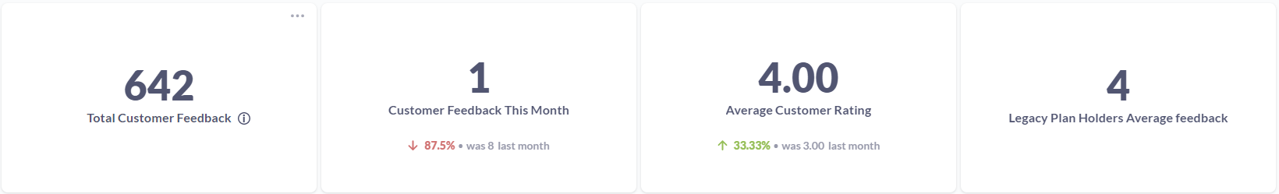

1. **Total customer feedback** stands at **642.**
2. **Decrease** in monthly customer feedback to **87.5%;** from **8** to **1.**
3. The average monthly customer rating stood at **4** stars, an **increase** from **3** representing a **33.33% rise.**
4. The **monthly targets (5 stars)** have been met **thrice** in the last 10 years. While the **lowest average** monthly **customer rating (2)** has happened twice in the last 10 years.

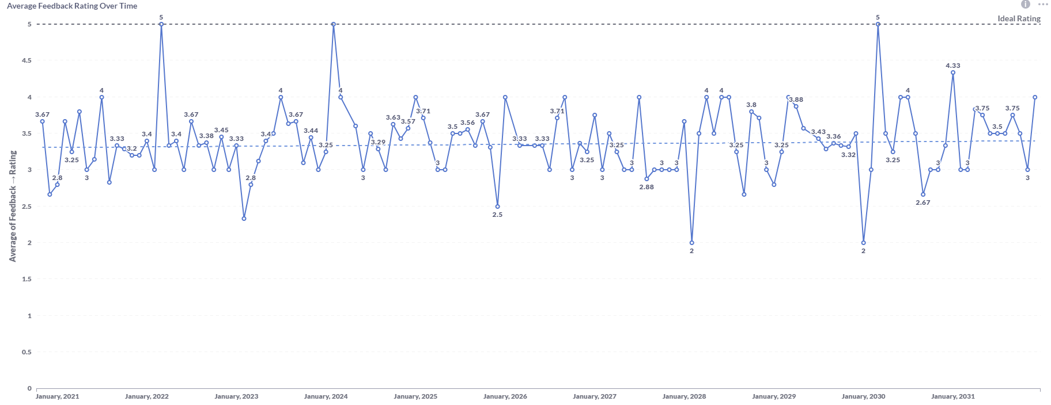

1. The **Basic plans** have the **highest** feedback **count (607)**, the **Premium plan** the s**econd highest (26),** and **the Business plan (9)** the **lowest.**

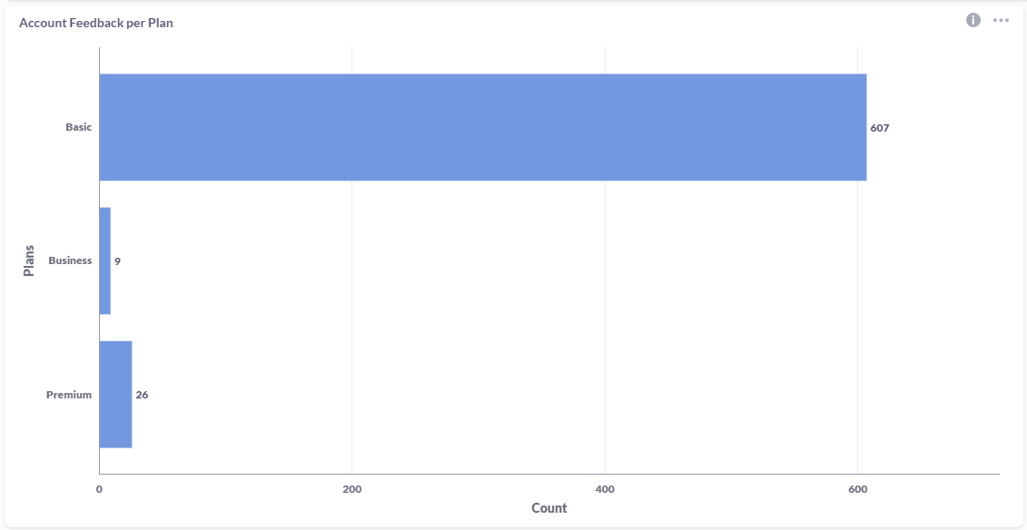

1. A **majority (640)** of the **legacy plan** users provided feedback while a **minority (2)** **failed** to provide feedback.

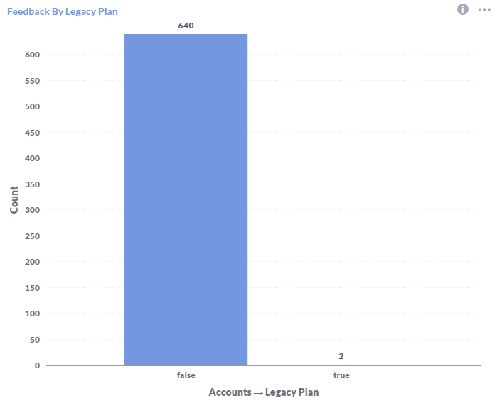

1. **Most** users provided an **“Average”** rating, and **a “poor”** rating as the least number of users with **“Good”, “Below Average”**, and **“Great”** taking second, third, and fourth respectively.

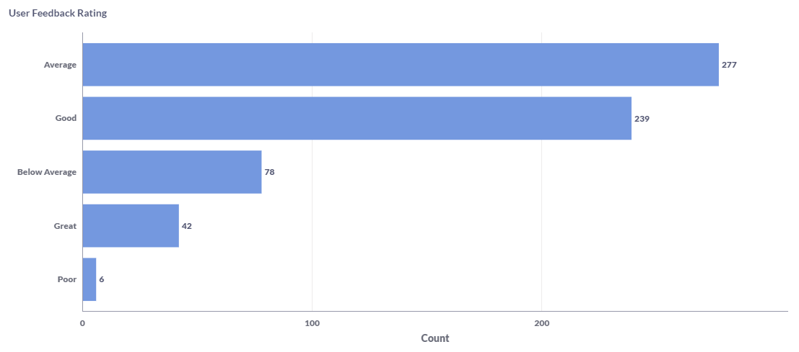

# Summary of Business Problem and Recommendations

|  |  |  |
| --- | --- | --- |
| KPIs | Business Problem | Recommendation |
| Revenue Targets | Piespace Failed to Reach Monthly Revenue Target. | 1. Review and adjust the pricing strategy to align with market dynamics and customer preferences. 2. Improve marketing and sales efforts to enhance customer acquisition and conversion rates. 3. Focus on customer retention strategies to strengthen loyalty and recurring revenue. |
| Revenue by category and Average price by category. | Doohickey had the lowest revenue by product while having the lowest average price. | 1. Review and adjust the pricing strategy to better reflect product value and market positioning. 2. Conduct a competitive analysis to identify areas of differentiation and assess pricing competitiveness. 3. Enhance the value proposition of products through additional features or customization options. 4. Identify target market segments willing to pay higher prices and tailor marketing efforts accordingly. 5. Optimize marketing and sales strategies to improve brand awareness and messaging. |
| Average monthly product rating | Monthly average product rating dropped by 17.34% | 1. Enhance product quality and address any issues raised in customer feedback. 2. Streamline customer support processes to ensure prompt and satisfactory resolution of issues. 3. Implement a systematic customer feedback loop to gather insights and communicate actions taken. 4. Improve the user experience by making the product more intuitive and user-friendly. 5. Foster a culture of continuous improvement and iterate the product based on market trends and feedback. |
| Quantity of products ordered per Quarter | Gadget and Widget recorded the lowest quantity ordered in the last quarter | 1. Review the pricing strategy and ensure competitiveness in the market. 2. Improve marketing and promotional efforts to enhance brand awareness and communicate value propositions. 3. Provide sales team training and support to effectively sell Gadget and Widget products. |
| Monthly User Growth | User growth decreased by 76.12% | 1. Enhance the user onboarding process to ensure a smooth and engaging experience for new users. 2. Develop strategies to increase user engagement and drive long-term retention. 3. Optimize marketing and advertising campaigns to attract new users, utilizing data-driven techniques. 4. Implement referral and loyalty programs to encourage user growth and retention. |
| Active Subscriptions | Active Subscribers dropped by 33.33% | 1. Evaluate pricing structures and competitiveness to provide better value to customers. 2. Assess and enhance subscription benefits and features to make them more appealing. 3. Implement proactive customer engagement and communication strategies to maintain subscriber interest. |
| Trial Account Conversion | Trial accounts dropped by 61.54% | 1. Evaluate and streamline the trial onboarding process to remove any friction points. 2. Refine the value proposition and communicate the benefits of the product or service. 3. Optimize communication channels to provide timely and relevant information to trial users. 4. Implement personalized and targeted approaches to engage trial users. 5. Consider offering trial extensions or additional incentives to encourage conversion. |
| Social media Trial conversion | Twitter was the least effective social media platform to convert accounts | Analyze the target audience to determine if Twitter aligns with the company's demographic.  Reassess social media channel selection and prioritize platforms with higher conversion rates.   1. Develop a tailored content strategy for Twitter that engages the platform's unique audience. 2. Utilize targeted advertising on Twitter to reach users who are more likely to convert. 3. Actively engage with users on Twitter to build relationships and enhance brand perception. 4. Implement robust tracking and analysis to monitor the effectiveness of Twitter campaigns. 5. Conduct A/B testing to optimize the content and strategies used on Twitter. 6. Benchmark competitors' successful strategies on Twitter and adapt them to fit the company's unique value proposition. |